Nakayoshi Gakko
Pick up Buckets

Arts and Crafts Committee

Class: Taiko

Project: Taiko Drums

Material: Buckets

Qty. Needed: 17

Instructions: Remove handles.

Drill two 1/2” diameter holes on one side of the bucket as pictured in the diagram below.
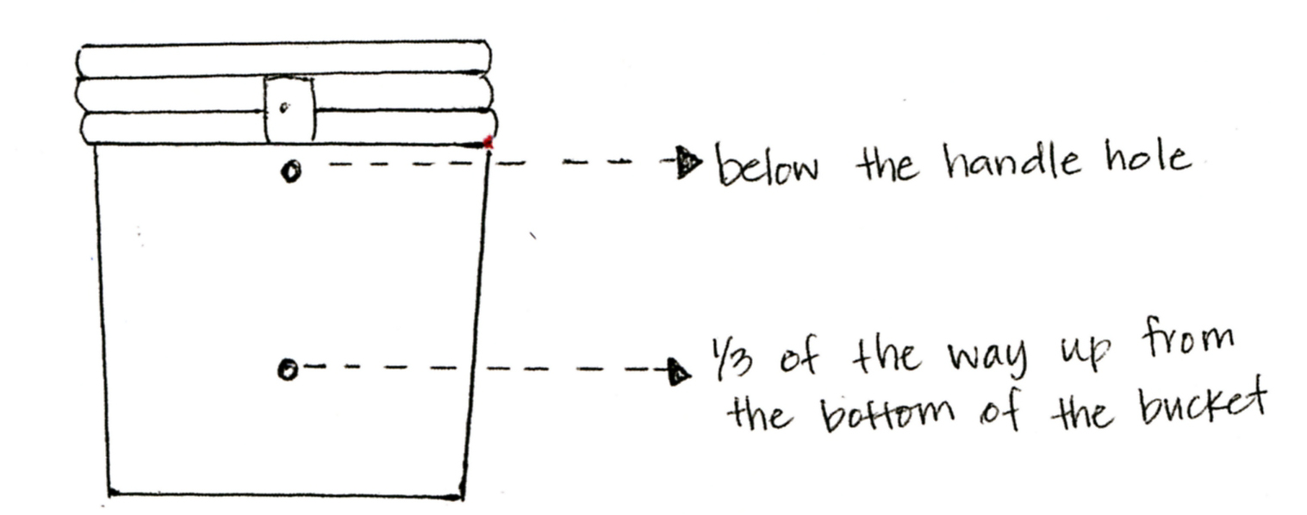

Date Due: Bring completed project with you on Maintenance I Day prior to the start of session. Please return the sample and any unused supplies.

Thank you in advance for your help! ☺

